

By: Your Organization

Contact Name

Email

Website

**FUNDING**

**Grant Award:**

**Total Match:**

**Total Project Cost:**

**PARTNERSHIP IS KEY**

**Please list any partnerships and their contribution to your project - Approximate length: maximum 550 characters and spaces allowed, Ariel 10 point bold**

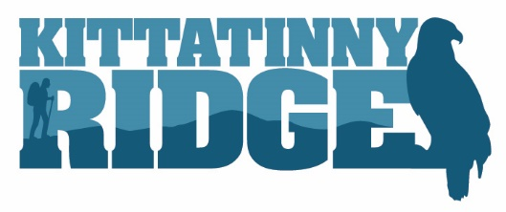

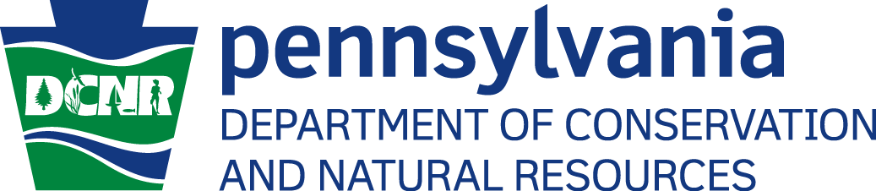

**DON’T REMOVE/ALTER THESE LOGOS]**

PLEASE INSERT PHOTO TO REPLACE THIS PHOTO PLACEHOLDER WITH A PHOTO THAT BEST REPRESENTS YOUR SPECIFIC PROJECT.

Your logo here – you can also add partners’ logos if appropriate.

Kittatinny Ridge

SUCCESS STORY

**CHALLENGE**

Please explain why the project was necessary and what need was addressed in your community through this project - Approximate length: maximum 1,075 characters and spaces allowed Ariel 10 point.

**SUMMARY**

Brief Summary of Project - Approximate length: maximum 645 characters and spaces allowed Ariel 11 point.

**Your Project’s Name Here**

**Contact**

**Jeanne Ortiz,**

**Program Manager Landscape Conservation**

Audubon Pennsylvania

1201 Pawlings Road

Audubon, PA 19403

215-519-5648

jortiz@audubon.org

Insert additional picture here if desired.

**RESULTS**

If quantifiable, please include statistics/If qualitative, please include observations, quotes, etc. - Approximate length: maximum 1,280 characters and spaces allowed Ariel 10 point.

**SOLUTION**

How your project filled this need - Approximate length: maximum 750 characters and spaces allowed Ariel 10 point.

Place additional photo(s) here – 4 photos maximum (i.e. before, during, after photos)