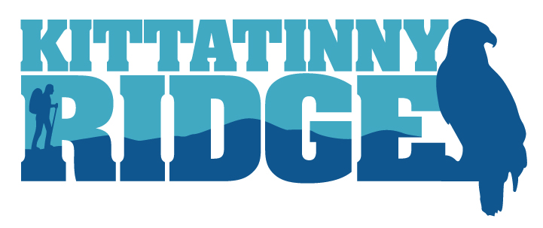
2018 - 2019 MINI-GRANT PROGRAM
INSTRUCTIONS AND GUIDELINES

Content Includes:
- General Information
- Eligibility
- Application Submission Process
- Application Review Process
- Grant Application Checklist

For Questions and Additional Information Contact:
Jeanne Ortiz, Program Manager, Landscape Conservation
Audubon Pennsylvania
1201 Pawlings Road
Audubon, PA 19403
215-519-5648
jortiz@audubon.org

GENERAL INFORMATION

The Kittatinny Coalition is a group of land trusts, conservation organizations, state and federal government agencies, and academic institutions working together to conserve the natural, scenic, cultural, and aesthetic resources of the Kittatinny Ridge and Corridor. The Kittatinny project, and this mini-grant program, is supported by the Pennsylvania Department of Conservation and Natural Resources (DCNR) through DCNR’s Environmental Stewardship Fund administered by the Bureau of Recreation and Conservation. The DCNR grant is administered by the Kittatinny Coalition through Audubon Pennsylvania. For more information on the Kittatinny Ridge project visit www.kittatinnyridge.org.

The Kittatinny Coalition has a total of $40,000 for the 2018 - 2019 Mini-Grant Program. A mini-grant committee will award grants up to $10,000 for projects that support and advance the goals of the Kittatinny Coalition and Pennsylvania Wildlife Action Plan, as described below. All projects, related costs and funding must conform to the guidelines of the PA DCNR Community Conservation Partnership Program: www.dcnr.state.pa.us/brc/grants/index.aspx.

Grant Agreement and Disbursement
Awardees will enter into a Grant Agreement with Audubon Pennsylvania to receive the mini-grant funds. Once the Agreement is fully executed, Awardees can receive 50% of the award amount and upon invoice thereafter. Ten percent of the mini-grant award will be paid upon completion of the Scope of Work. Awardees must submit an interim progress report and final project report. All project deliverables must be submitted no later than the grant’s project completion date.

Match Requirements
Mini-grants require a 1:1 local match in the form of cash and/or eligible non-cash (in-kind) services.

Cash Match:
No portion of the cash match can originate from DCNR funding, including but not limited to:

Community Parks and Recreation Grants
Land Acquisition Grants
Partnership Grants
Trail Grants
Rivers Conservation and Riparian Buffer Grants

In-kind Match:
The value of municipal labor and/or professional services is equal to the hourly billable rate multiplied by the number of hours performing that service or job. The value of volunteer in-kind will be valued at the current Independent Sector Volunteer Rate for Pennsylvania at the time the work was performed please visit https://independentsector.org/news-post/value-volunteer-time for current volunteer value.

Applicants must provide proof of match commitment.

Important Dates
- Grant round opens: April 6, 2018
- Application deadline: May 31, 2018
- Grant awards announced: June 22, 2018
- Interim report due: March 29, 2019
- Project completion and final report due: December 15, 2019
- Awardee mini-grant presentations: Kittatinny Coalition annual meetings, to be determined
ELIGIBILITY

Who is eligible?
Eligible applicants include non-profit organizations with tax-exempt status 501(c)(3), municipalities, counties, and educational institutions.

Non-profit organizations must submit proof of non-profit status and be registered with the PA Department of State Bureau of Charitable Organizations.

Current DCNR Partnerships Program grant recipients are discouraged from applying for or receiving mini-grants.

What kind of project is eligible?
This mini-grant program supports two goals of the Kittatinny Coalition: 1) to conserve the mosaic of habitats that support species diversity, and 2) to promote the scientific study of the Ridge and facilitate the exchange of information regarding habitats, wildlife, conservation management activities, history and human communities to support and inform all other goals of the Coalition.

Below are four categories of projects that will be considered for funding.

Category 1: Habitat
Carry out research or restoration efforts aimed at understanding, creating and/or maintaining high quality native habitat along the Ridge. Focus may pertain to species of special concern, rare or exemplary natural communities, climate change resiliency, the creation/restoration of a mosaic of ecologically functional habitat, invasive species management, and similar projects in line with the goals of the Kittatinny Coalition.

Category 2: Pennsylvania Wildlife Action Plan
Carry out research, monitoring, habitat assessments or restoration directly benefiting highest priority Species of Greatest Conservation Need (SGCN) as identified by the Pennsylvania Wildlife Action Plan.

Included with the application packet is a list of SGCN that the Coalition is focusing on in 2018 - 2019. Research and survey needs for SGCN can be found in the Wildlife Action Plan species accounts (Appendix 1.4 – birds, mammals, reptiles, amphibians, fishes, and threatened or endangered mussels. Other invertebrate SGCN actions can be found in Appendix 1.1), which applicants are encouraged to reference in their proposal development.

Category 3: Water
Study the role of the Ridge and its natural resources in protecting headwater sources and public water. Investigate the dependency and degree to which Ridge water is utilized for public drinking water. Implement local watershed protection and restoration plans along the Ridge. Implement Cold Water Conservation Plan recommendations that benefit the Ridge. See http://www.coldwaterheritage.org.

Category 4: Education and Outreach
Design and implement programs to educate communities along the Ridge about the benefits the Ridge provides. Focus could be ecosystem services, economic services, health and wellness benefits, and similar projects in line with the goals of the Kittatinny Coalition.

Projects must be located within the Kittatinny Ridge Corridor, which encompasses townships that run along the spine of the Ridge as illustrated in the map below.

What kind of project is ineligible?
• Recurring maintenance or monitoring
• Maintenance of existing structure or construction or rehabilitation of structures that are not directly related to preservation or restoration of natural resources
• Permanent staff salaries
• Property easement or acquisition activities

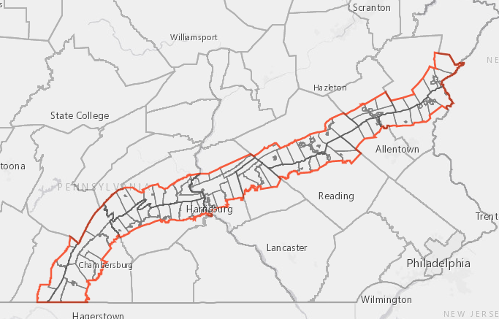

APPLICATION SUBMISSION PROCESS

Format:
- The application can be downloaded from the Kittatinny Coalition website at www.kittatinnyridge.org.
- Application narratives should be clear and concise.
- The application must be submitted electronically.
- All required supporting documents should be attached as either WORD or PDF documents and should be identified as your application’s documents.

Submission:
  - Electronic applications must be received by 5:00 pm on May 31, 2018. Subject Line should read “Kittatinny Coalition Mini Grant Application.”
  - Email applications to Jeanne Ortiz at jortiz@audubon.org.
  - All applicants will receive an email confirmation of receipt of application. If you do not receive this email – you need to contact Jeanne Ortiz by phone at 215-519-5648 to ensure that your application was received and will be considered.
  - E-mailed applications received after 5:00 pm on May 31, 2018 will not be considered.

DCNR Citation:
Awardees must include this DCNR funding citation on any printed materials or products: “This project is supported by the Pennsylvania Department of Conservation and Natural Resources through DCNR’s Environmental Stewardship Fund administered by the Bureau of Recreation and Conservation.”

APPLICATION REVIEW PROCESS
Applications will be ranked by a review committee composed of Kittatinny Coalition Mini Grant Committee members. The review committee reserves the right to request additional proposal information.
Applicants will be ranked based on how well the project:
  - Supports and advances the goals and objectives of the Kittatinny Coalition as described in the application materials.
  - Can be completed by December 15, 2019.
  - Promotes partner collaboration.
  - Identifies and secures required match.
  - Develops a realistic budget.
  - Demonstrates that project will have measurable outcomes and be successful.

SCORING | POINTS
Project Details
Project Description and Scope of Work: Is the project well developed and adequately explained? | 10
Project Timeline: Does the applicant have the capability to be successful and complete the Scope of  Work by December 15, 2019? | 5
Partners & Collaboration: Does the project involve and adequately explain collaboration with other  partners? | 5
Consistency with Plans
State/Local Plans: Is this project consistent with state and/or local planning priorities? Does the applicant  adequately explain how the proposed projects is consistent with identified plan(s)? | 5
Kittatinny Coalition/SWAP Goals: Does the proposed project advance the mini grant goals of the Kittatinny  Coalition and Pennsylvania Wildlife Action Plan? Does the applicant adequately explain how the project  advances these goals? | 10
Effectiveness: Will the outcome and activities of the proposed project implement the identified project  goals? | 5
Budget
Proposed Budget: Is the budget reasonable and adequately support the stated goals and Scope of Work  for the project? | 5
Local Match: Is local match secured and documented with letters of commitment? | 5
TOTAL POSSIBLE SCORE | 50

GRANT APPLICATION CHECKLIST
Completed application narrative, including Kittatinny Coalition and Pennsylvania Wildlife Action Plan goals supported by the proposed work.

Completed budget with documented match (50% or greater) not from other DCNR funding.

Current proof of IRS 501(c)(3) non-profit status and registration with the PA Bureau of
Charitable Organizations.

Letters of commitment from partners.

